1. Counting Elements Given an integer array arr, count how many elements x there are, such that x + 1 is also in arr. If there are duplicates in arr, count them separately. Example Input: arr = [1,2,3] Output: 2 Explanation: 1 and 2 are counted cause 2 and 3 are in arr. Example 2: Input: arr = [1,1,3,3,5,5,7,7] Output: 0 Explanation: No numbers are counted, cause there is no 2, 4, 6, or 8 in arr. Constraints: ● 1 <= arr.length <= 1000 ● 0 <= arr[i] <= 1000

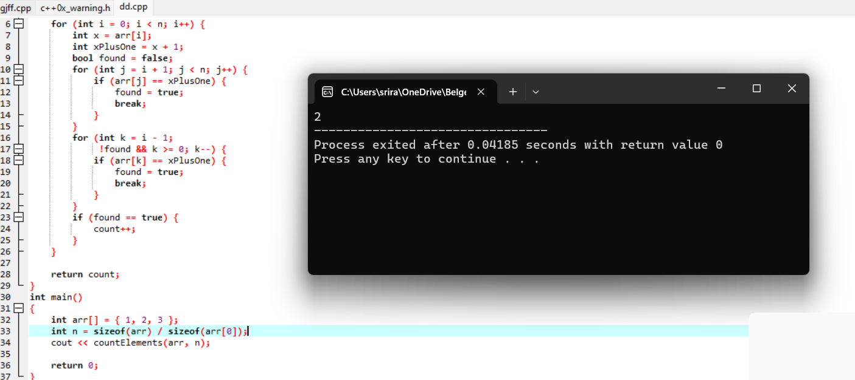

1. Perform String Shifts You are given a string s containing lowercase English letters, and a matrix shift, where shift[i] = [directioni, amounti]: ● directioni can be 0 (for left shift) or 1 (for right shift).

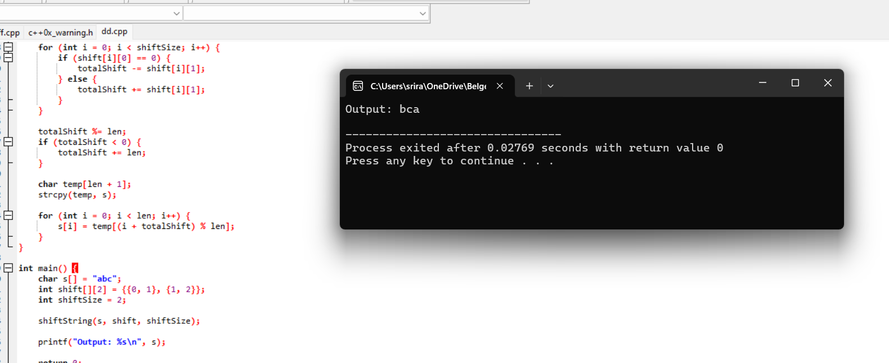

1. Leftmost Column with at Least a One A row-sorted binary matrix means that all elements are 0 or 1 and each row of the matrix is sorted in non-decreasing order.

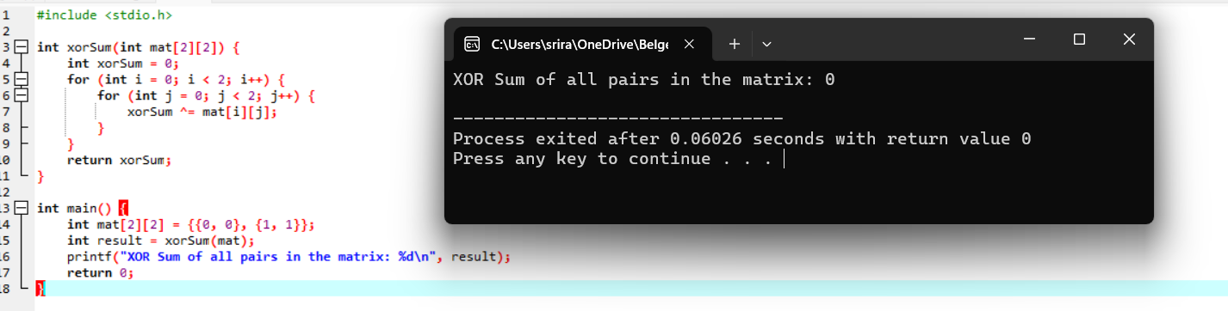

1. First Unique Number You have a queue of integers, you need to retrieve the first unique integer in the queue.

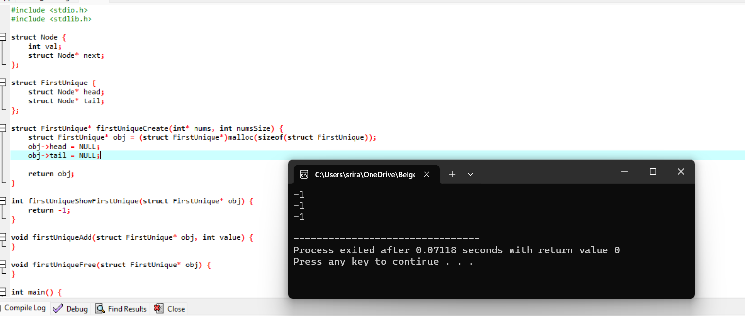

1. Check If a String Is a Valid Sequence from Root to Leaves Path in a Binary Tree Given a binary tree where each path going from the root to any leaf form a valid sequence, check if a given string is a valid sequence in such binary tree.

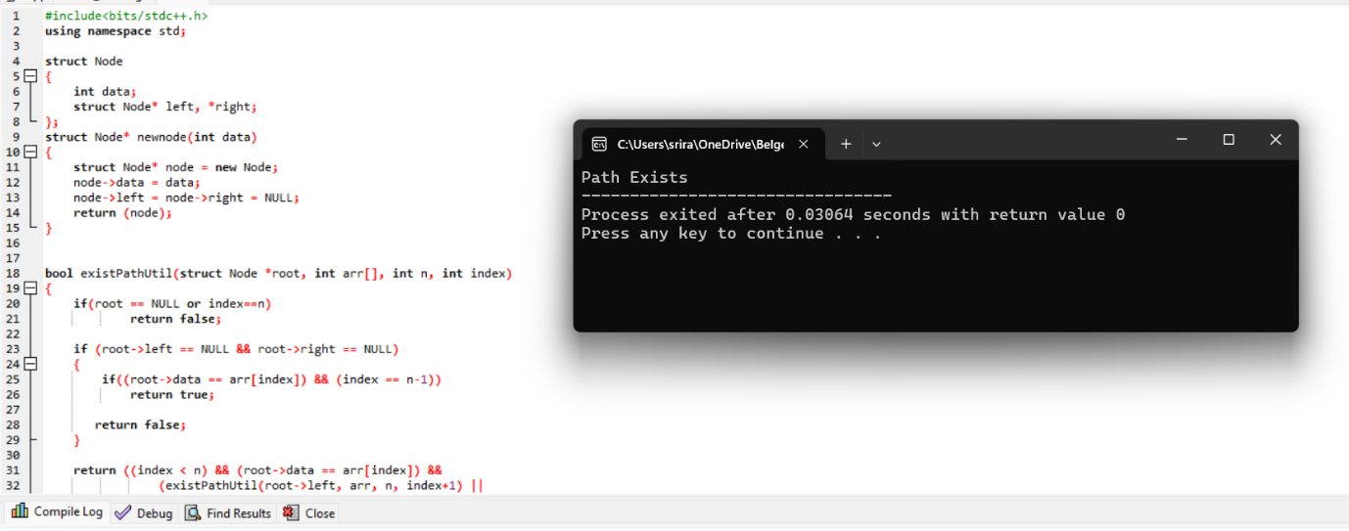

1. Kids With the Greatest Number of Candies There are n kids with candies. You are given an integer array candies, where each candies[i] represents the number of candies the ith kid has, and an integer extraCandies, denoting the number of extra candies that you have.

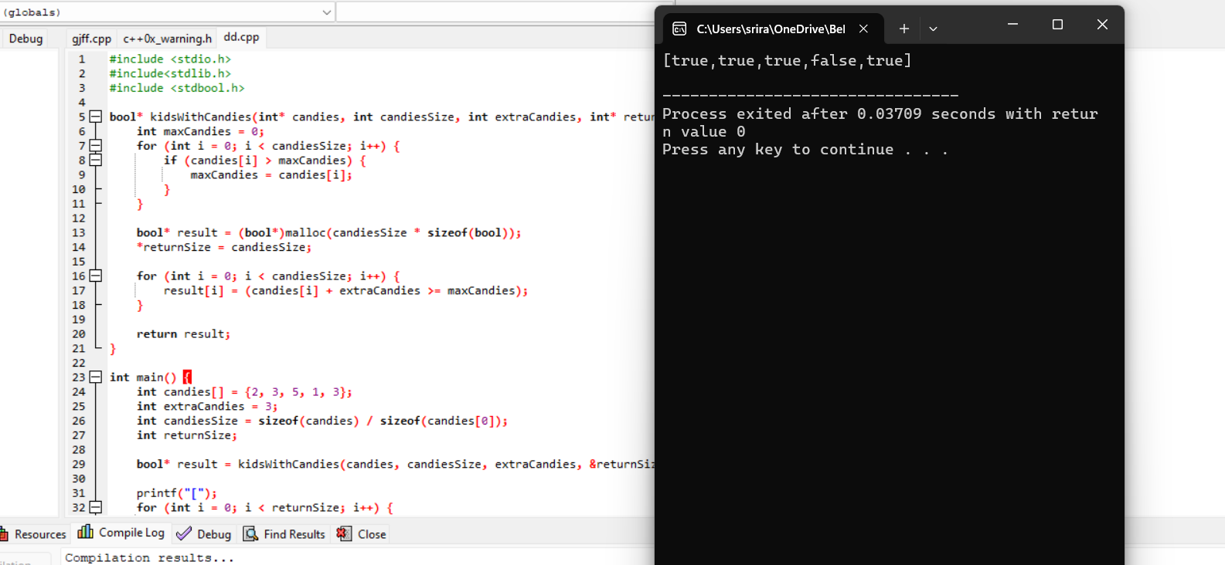

1. Max Difference You Can Get From Changing an Integer You are given an integer num. You will apply the following steps exactly two times: ● Pick a digit x (0 <= x <= 9). ● Pick another digit y (0 <= y <= 9). The digit y can be equal to x. ● Replace all the occurrences of x in the decimal representation of num by y.

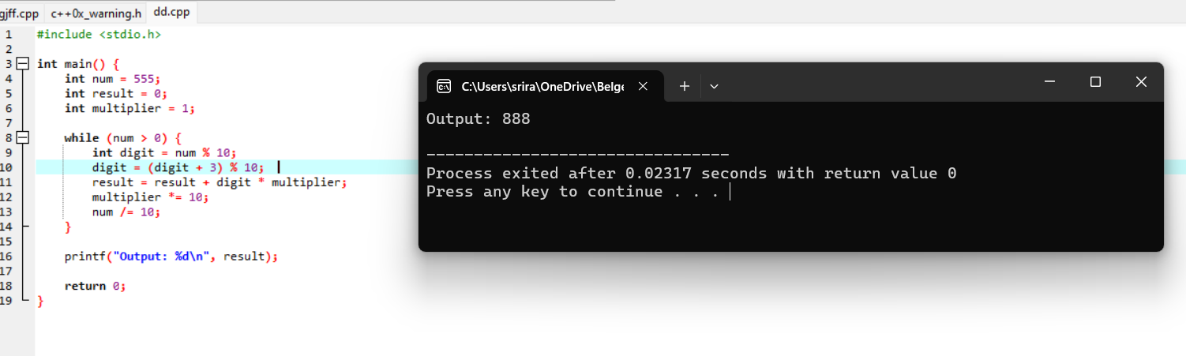

1. Check If a String Can Break Another String Given two strings: s1 and s2 with the same size, check if some permutation of string s1 can break some permutation of string s2 or vice-versa.

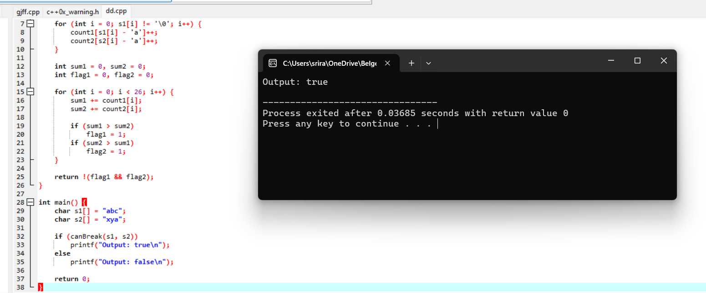

1. Number of Ways to Wear Different Hats to Each Other There are n people and 40 types of hats labeled from 1 to 40. Given a 2D integer array hats, where hats[i] is a list of all hats preferred by the ith person. Return the number of ways that the n people wear different hats to each other. Since the answer may be too large, return it modulo 109 + 7.

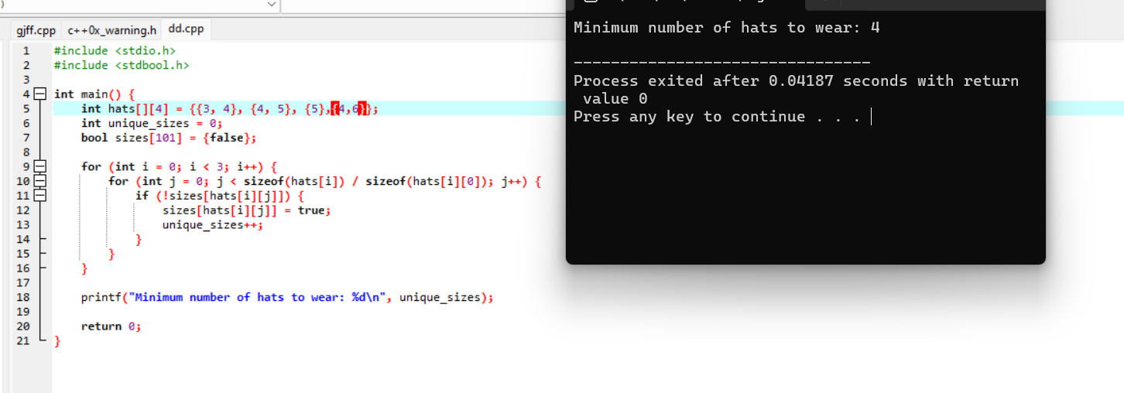

1. Destination City You are given the array paths, where paths[i] = [cityAi, cityBi] means there exists a direct path going from cityAi to cityBi. Return the destination city, that is, the city without any path outgoing to another city. It is guaranteed that the graph of paths forms a line without any loop, therefore, there will be exactly one destination city.

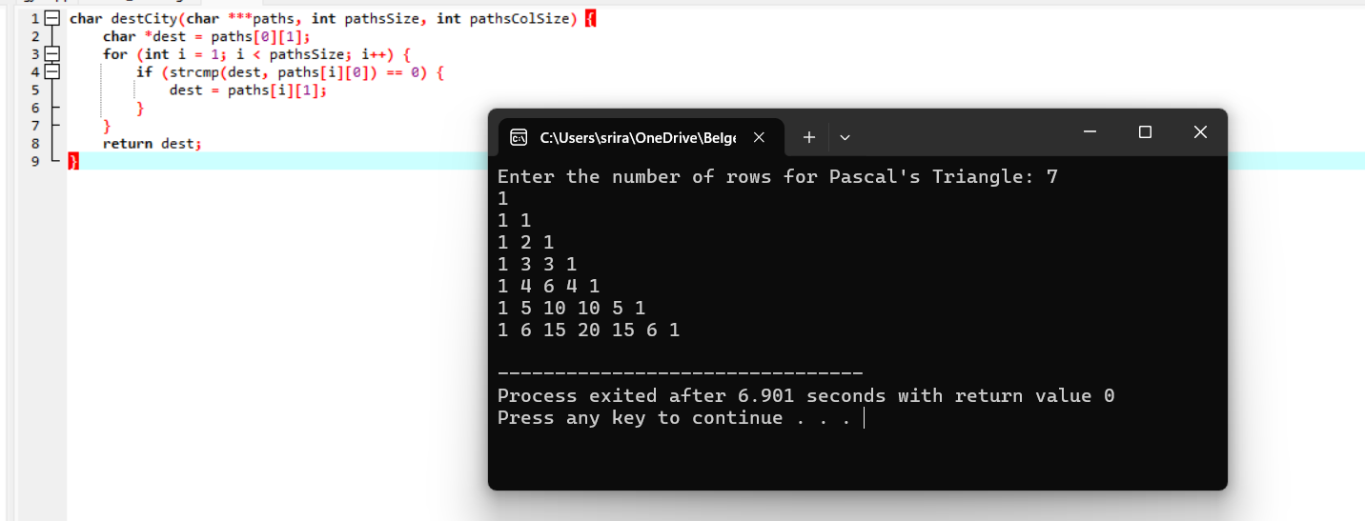

1.Write a program to find the perfect number.

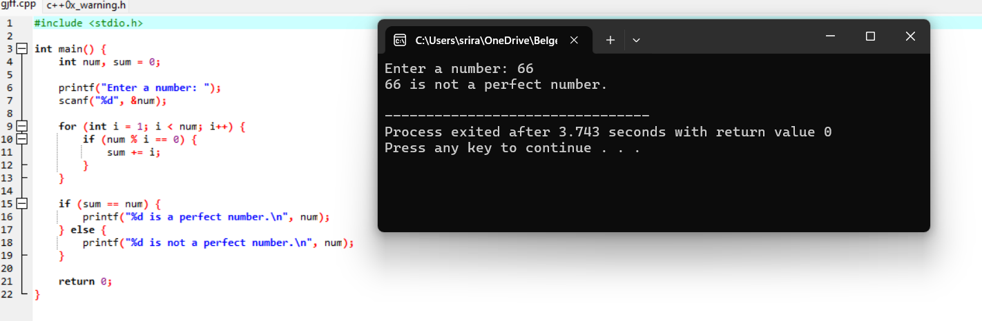

2.Write a program to perform travelling salesman problem using dynamic programming

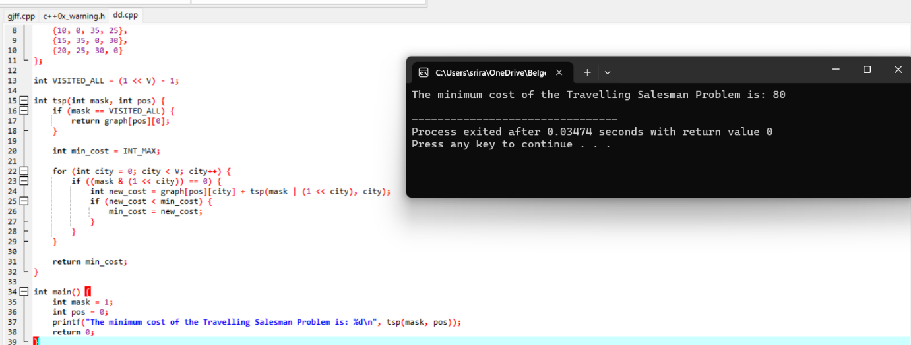

3.Write a program for the given pattern

If n=4

1

1 2

1 2 3

1 2 3 4

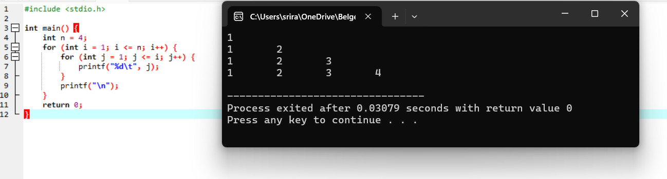

4.Write a program for pascal triangle.

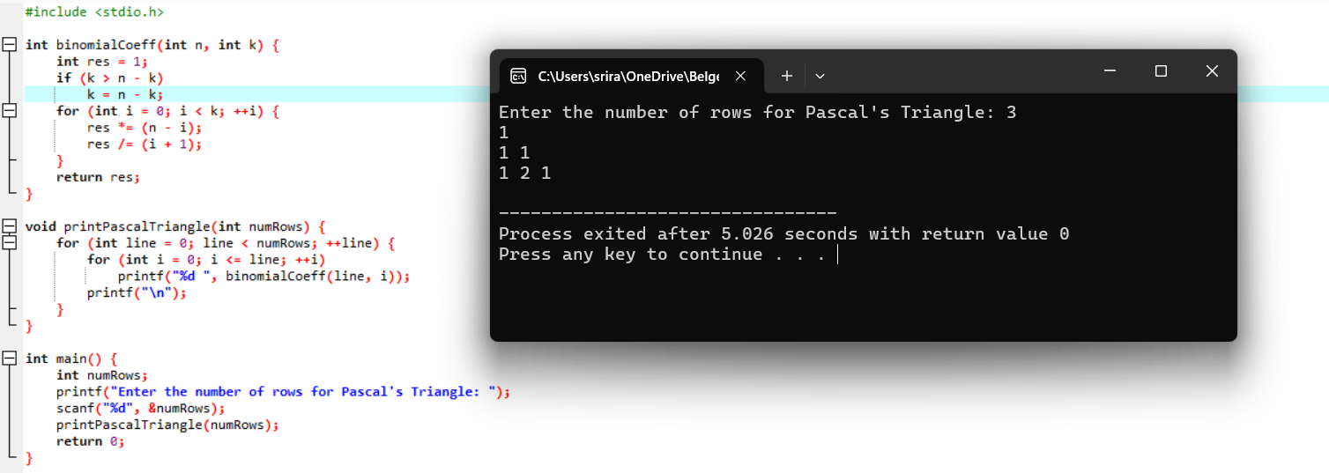

5.Write a program to find the sum of digits.

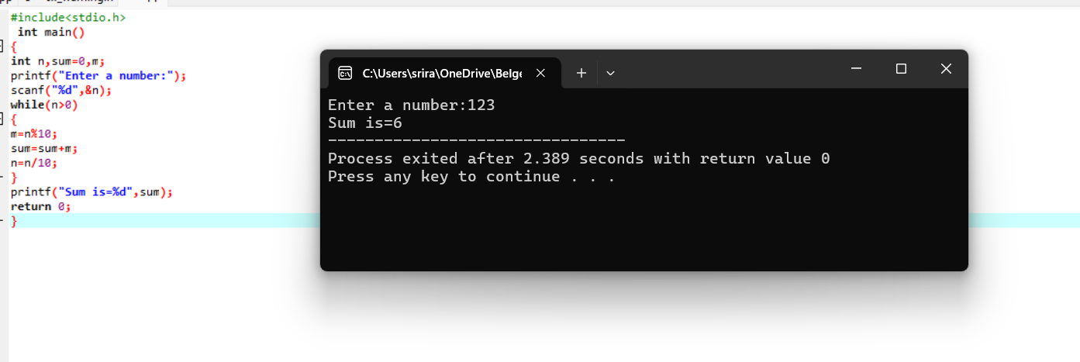

6.Write a program to print a minimum and maximum value sequency for all the numbers in a list.

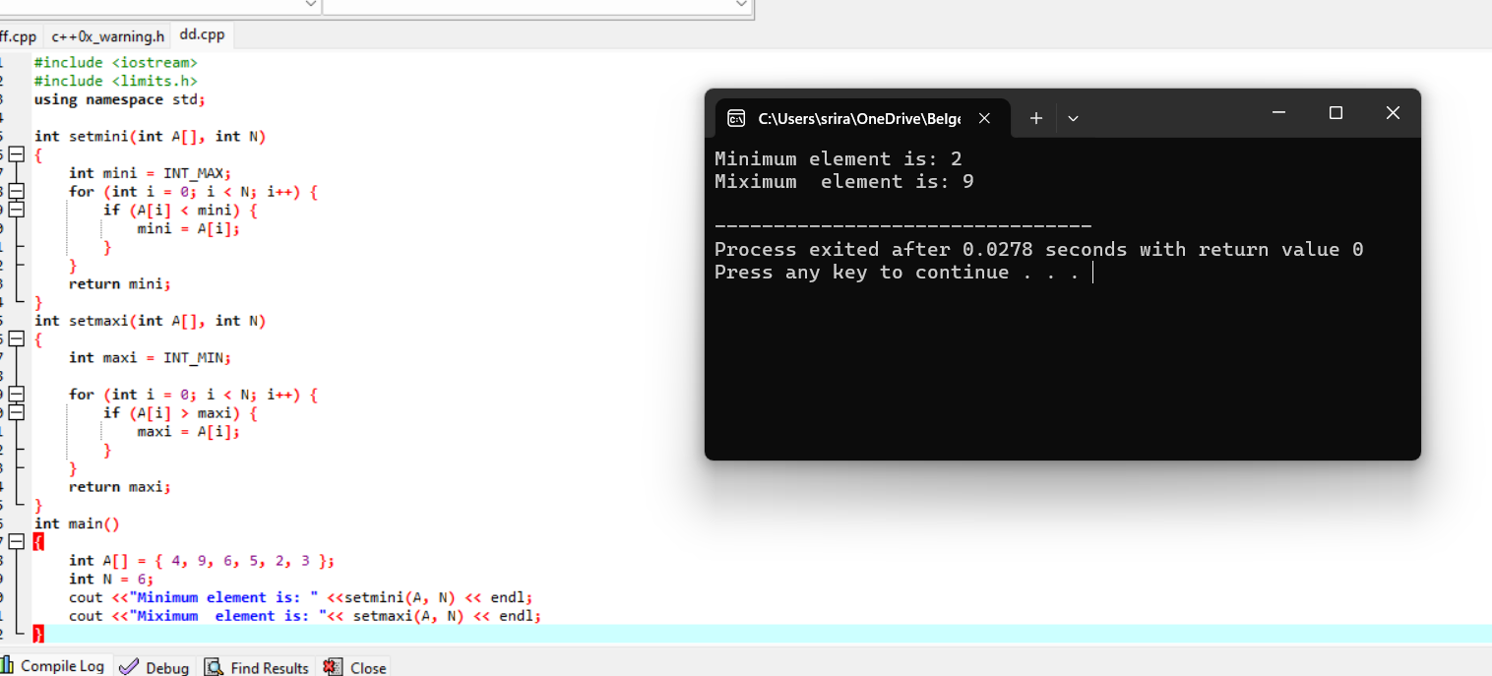

7. Write a program to inset a number in a list.

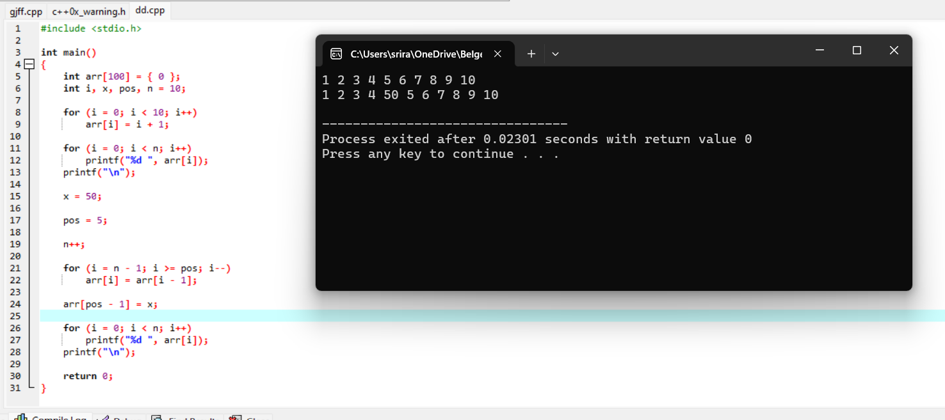

8. Write a program to generate the list of all factor for n value.

